VM_cleaner usage:

After all automatic installations of dependencies we get following screen:

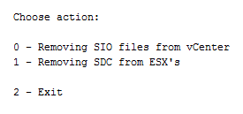

1. Cleaning vCenter

Script checks version of vCenter (5.5 or 6.0), stop web client service, remove all relevant files and folders, start web client service

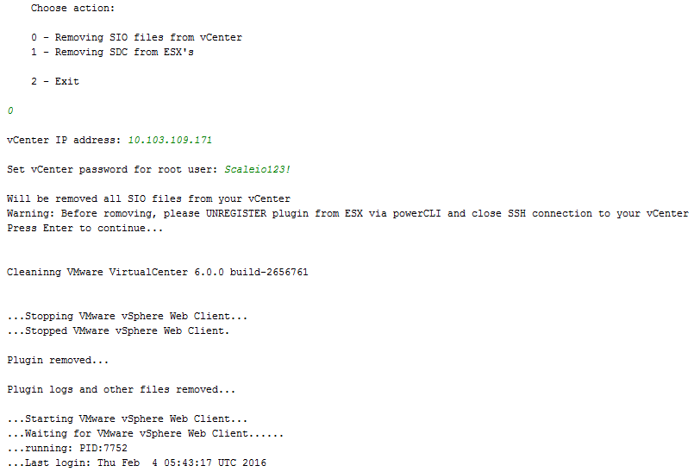

2. Removing SDC from ESX

a. Set ESXes for removing (max 8)

b. Remove SDC from ESXes

c. Reboot ESXes

Script check version of ESX and remove files from relevant pathes

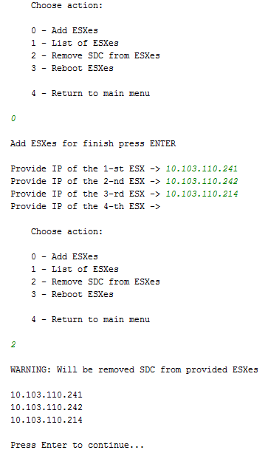

P.S. Script doesn’t do automatic reboot after removing SDC, in practice sometimes you need to do just reboot without removing (for example after install SDC on ESX)